ORION Telemetric System MRIT
- Provides a fast full-body evaluation test
- ORION system is based on advanced research in homeostasis and informational technologies
- Targeted for early recognition and prevention of future disease
- Monitors and decodes cellular oscillations
- Safe for patients and healthcare practitioners
- Easy to operate
- Easy to carry
- Produces 3D images
How the technology works
Non-linear spectra and the slow oscillations of the vortex magnetic fields of the biological molecules are measured.
Quantum entropy logic and fractal mathematical analysis are used to interpret the energy status of the cells and their capacity to remain stable within their biological and chemical environment.
Monitoring biological structures
ORION software makes it easy to monitor the states of the body’s various systems. Each organ or pathological process can be displayed on the screen as a graph representing the information exchange between the organ tissue and its environment. In addition, ORION integrates information gathered during different sessions, enabling the healthcare practitioner to monitor any dynamic changes that may occur with time.
Evaluation of Pathology
The system allows a healthcare practitioner to compare a particular reading to the metrics of a normal, healthy organ. After reading the frequency characteristics for a particular organ, the equipment can compare the degree of the spectrum similarity to reference data.
Orion defines healthy organs, pathology-affected tissues, or infection agents. It then defines the closest pathological process or a tendency to develop such process.
The Orion Bioscan uses a number of various tools in evaluating and analyzing biological systems such as telemetric biofeedback, a visual rating on Flander’s scale, entropy analysis, the non linear system analysis, etc.
Compatibility of Medications
The ORION system records the frequency fluctuations of any medicine evaluating medicines together with a patient’s data, ORION can pin-point the most efficient remedy for the patient.

Orion Therapy
- Once the pathology is identified, the body can be influenced through a combination of balancing electromagnetic signals from ORION. This method is very effective for pain management, heart and lung related problems, chronic fatigue syndrome as well as early prevention of diseases.

- The advanced model-Orion Platinum also includes a micro-current module which covers a frequency range from o to 600 Hz and has 39 pre-set programs for a variety of applications such as skin rejuvenation, lymph drainage and cellulites treatment.

Orion is useful to the healthcare practitioner for:
- Making a quick evaluation of the patient’s conditions by recording changes in organs, histological or cytological structures.
- Predicting stages in treatment or development of complications.
- Substantially reducing the time and expense of evaluating a patient’s condition.
- Showing the patient dynamics of condition improvement over time.
- Assessing the adaptive capability of organs and tissues.
- Making an analysis of the dynamics of change in the functional state of the body in the course of treatment.
- Revealing the primary nature of the cause of functional disturbance.
- Defining the character of pathology.
- Assessing the variables of homeostasis
Orion Examination
Primary issues can be identified through comparison of measured values to the absolute model.
Improvement or worsening of any condition can be presented on a quantitative scale from 1 to 6.
A change from a larger to a smaller value (from 5 to 2) signifies improvement.
A change from a smaller to a larger value (from 2 to 5) signifies worsening.
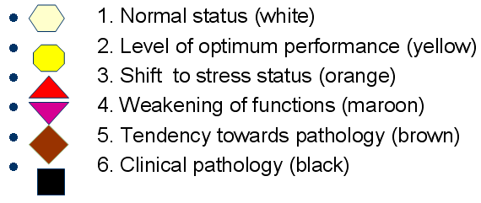
Clinical Trials
ORION MRIT was tested on 1876 patients:
Males: 862
Females: 1014
Age 17 to 83, majority over 40
Accuracy – 80 to 90% (median 82 %)
Sensitivity – 79.3 %
Specificity – 87.2 %

Conclusion:
- ORION MRIT is recommended as sensitive, accurate and specific investigative technology
- Efficient and safe for both doctors and patients
- Non invasive, no radiation
- Fast to operate
- Easy to use
- Provides in-depth analysis
- Enables preventative diagnosis and early recognition of diseases
Applications:
- Private clinics (expensive lab equipment is not needed)
- Medical laboratories
- Educational and Research Institutions-Nanotechnology (Novel and Advanced Knowledge-Cell Bio Physics)
- Pediatricians
- Spa
- Nutritional Centers
Specifications:
Basic Model Orion Plus
Dimensions: 10” (L) x 7.5” (W) x 2.4” (H)
Weight: approx. 3.5 pounds

Orion Diamond:
Dimensions: 16.5” (L) x 8.75” (W) x 3” (H)
Weight: approx. 8 pounds

